Unit5

Daniel Byrne

9/24/2019

Slide 1: Use Aic5 to assess the use of ARMA models in the Walmart data.

aic5.wge(Stor9Item50$sales)

## ---------WORKING... PLEASE WAIT...   
##   
##   
## Five Smallest Values of aic

## p q aic  
## 15 4 2 4.991650  
## 17 5 1 5.009865  
## 18 5 2 5.021469  
## 14 4 1 5.073902  
## 12 3 2 5.114417

Slide 2: Find p1 for the following model by hand. Xt = at–.8at-1 + .5at–2.

theta1 = .8  
theta2 = -.5  
p1 = (-theta1 + theta1*theta2)/(1 + theta1^2 + theta2^2)  
p1

## [1] -0.6349206

Slide 3: Represent the model as a GLP.

Xt = at–.8at-1 + .5at–2

Slide 4: Generate a realizations from an ARMA model. pick p and q. Include the ACF and spectral density.

gen.arma.wge(n=100, phi=c(1.6,-.9), theta=.8, vara=1, plot=TRUE)

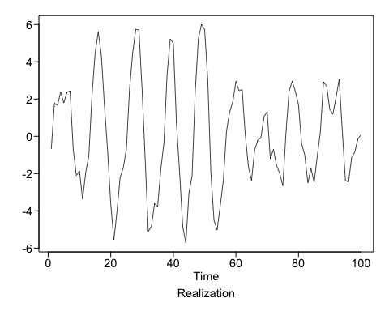

## [1] -0.68720398 1.77254219 1.66433078 2.38525713 1.79678783  
## [6] 2.35678935 2.43264108 -0.67839056 -2.09543202 -1.86025117  
## [11] -3.37597478 -1.93079728 -1.04173091 2.17253730 4.44343867  
## [16] 5.60725373 4.33961100 1.60232731 -0.76595531 -3.64031439  
## [21] -5.54747438 -4.03861621 -2.19643800 -1.69681565 -0.68193023  
## [26] 2.51504347 4.45039869 5.74815727 5.70188813 2.57166334  
## [31] -1.22766782 -5.09967952 -4.82299576 -3.60829730 -3.78176377  
## [36] -1.77221281 -0.34650742 3.29005762 5.21997831 4.99432330  
## [41] 0.70322179 -1.92417429 -4.82960933 -5.73194258 -3.03646946  
## [46] -2.12884399 2.39137636 5.23075568 6.00884866 5.72911628  
## [51] 3.03855405 -1.96568065 -4.50637827 -5.01610451 -3.73407133  
## [56] -2.34685421 0.27596725 1.31435252 1.83265536 2.94882835  
## [61] 2.44695799 2.50133820 0.07690895 -1.63734864 -2.36224799  
## [66] -0.72165054 -0.21615807 -0.06592761 1.06103795 1.31407881  
## [71] -1.19324901 -0.70089347 -1.55856913 -1.98881680 -2.65735053  
## [76] 0.18741242 2.41956502 2.95641075 2.40000682 1.70452082  
## [81] -0.38607240 -0.99317767 -2.50747451 -1.72138947 -2.48091918  
## [86] -1.07034423 0.23312032 2.92411712 2.69327803 1.44912995  
## [91] 1.19448726 2.08168702 3.04987582 0.32390600 -2.37317912  
## [96] -2.44636170 -1.13569226 -0.84549245 -0.14262252 0.07789034

Slide 5: Use AIC 5 to identify the top five quality models with respect to AIC for the cancelled flight data from the SWADelay.csv data set (column: arr_cancelled). Comment on which are AR, MA, and ARMA.

* row 1 AR Model
* row 2 MA Model
* row 3 AR Model
* row 4 ARMA Model
* row 5 MA Model

aic5.wge(swadelay$arr_cancelled)

## ---------WORKING... PLEASE WAIT...   
##   
##   
## Five Smallest Values of aic

## p q aic  
## 4 1 0 7.371886  
## 3 0 2 7.376428  
## 7 2 0 7.381147  
## 5 1 1 7.381751  
## 2 0 1 7.386961